Connecting pronunciation and grammar
by Mark Hancock
Grammar | Pronunciation
Clauses  - Relative clauses  - Conditionals  - Longer sentences  - Text | Intonation: tonality  separating into chunks using //  UNMARKED: coincides with clauses  MARKED: if it doesn’t, we ask why
Content words  - Verbs, nouns, adjectives…  - Compounds | Intonation: tonicity  placing tonic stress  UNMARKED: stress on last content word  MARKED: if not, we look for reasons
Function words  - Pronouns, articles, prepositions…  - Auxilliaries in tenses eg continuous | Rhythm  - stressing and unstressing words  - fitting stresses into regular beat  - weak forms
Morphemes  - -S endings  - -ED endings  - Other eg –ing; -est; er | Syllables  - when morpheme is extra syllable or not  - Linking  - Contractions
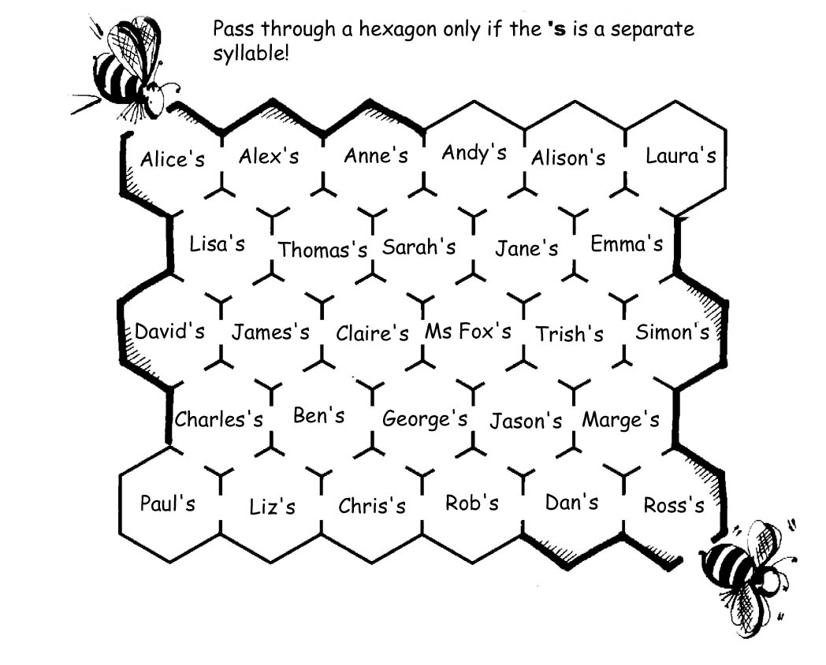
Grammatical Minimal Pairs

Part of speech
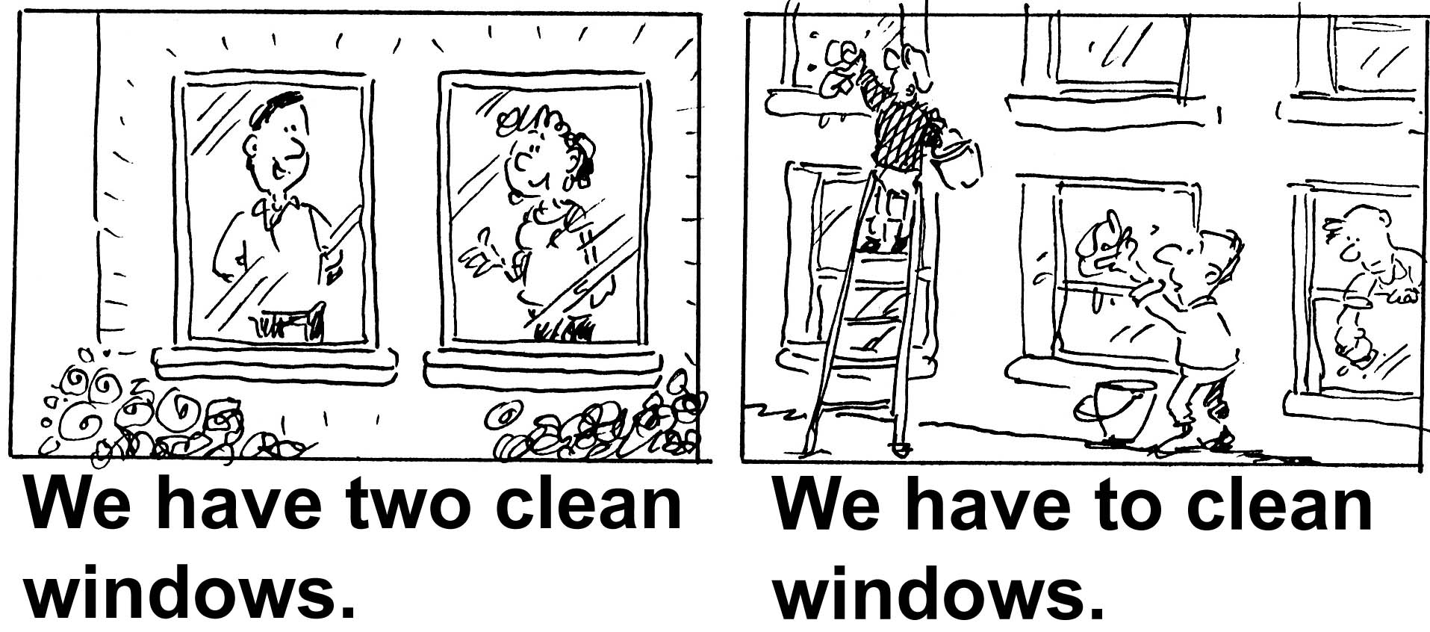

A Defining relative clause B Non-defining relative clause
The man who was lost asked for help. The man, who was lost, asked for help.
They stopped the driver who was speeding. They stopped the driver, who was speeding.
I changed the tyre which was flat. I changed the tyre, which was flat.

A Present B Past
The beach is crowded. The beach was crowded.
The rooms are noisy. The rooms were noisy.
The people are friendly. The people were friendly.
The place is nice. The place was nice.

I stop at the door. I stopped at the door.
I knock and I wait. I knocked and I waited.
I look in the window. I looked in the window.
I walk inside. I walked inside.
I turn round. I turned round.
The body moves. The body moved.

Contrastive stress  A | B
Waiter, this soup is cold!  Oh, did you want hot soup?  This soup isn't tomato!  Did you want tomato soup?  I wanted pea soup!  This is pea soup.  I don't want soup!  What do you want, then? | This is hot, but it isn't soup!  Oh, did you want hot soup?  This is tomato salad, not soup!  Did you want tomato soup?  What sort of soup is this?  This is pea soup.  My wife wanted soup; I didn't.  What do you want, then?

Sample Texts

In trouble at work…  B: Late again, Justin! // You’re ooooooalways late!  J: Not always, // Mr Minnit.  B: Yes, // you always arrive late!  J: But I never leave late!  B: Hmm // And how often do you oooooohave coffee breaks?  J: Not very often, // Mr Minnit.  B: But you’re always at the coffee oooooomachine // with Holly.  J: That’s not true. // I’m often at the oooooocoffee machine without Holly.  B: And another thing // Lunch break oooooois one hour // But you often take ooooootwo hours! // Explain that please!  J: Well // I sometimes go for lunch oooooowith Holly // and we add our lunch oooooohours together. //One and one oooooomake two!  People on bikes  / People on / bikes  / People on / buses  / Workers in their / offices  / Workers in their / factories  / Drivers in their / lorries  / Cars in the / car park  / Waiters in the / restaurant  / Glasses on the / tables  / Children in the / school  / Children in their / classes  / People in the / market  / People in their / houses | Nightmare Hotel  I walked up the hill  To the Nightmare Hotel  I stopped at the door  But I couldn't see the bell  I knocked and I waited  In the cold and windy night  I looked in the window  But there wasn’t any light  That’s when I noticed  The door was open wide  Then it started raining  So I walked inside  The door closed behind me  I asked ‘Who’s there?’  That’s when I noticed  The rats on the stairs  I turned round to leave  But I couldn't see the door  That’s when I noticed  The body on the floor  Then the body moved  The woman wasn’t dead  She told me her story  This is what she said:  I also walked up  To the Nightmare Hotel…

Some material above from English Result Elementary, a course book by Mark Hancock and Annie McDonald (OUP)

