Three takes on intonation

Mark Hancock suggests simple ways to start working on intonation.

There are three distinct aspects of intonation:
1 Separating what you say into groups of words;
2 Stressing the most important word in each of these groups;
3 Ending each group of words with the voice going up or down.

In this article, we’ll look at simple, practical ways of presenting intonation from each of these three ‘takes’ in turn.

Take 1: Grouping words

We can reinforce meaning in written English through punctuation. Similarly, we reinforce meaning in spoken English by audibly grouping words.

Reading aloud
Reading aloud is a familiar, time-honoured classroom procedure; not very communicative perhaps, but good practice for this aspect of intonation. This is because when your speech is scripted for you, it leaves you with attention to spare to think about delivery. A simple procedure is to ask the students to prepare by reading the text first and marking pauses with a slash (/). Remember there is no one correct answer here. Speakers may pause where they want to, either to breathe or to put more meaning into their delivery. Once the students have finished, encourage them to insert a few more pauses. Many learners read aloud too fast; more pauses will help them slow down.

Making a difference
Another approach to grouping words is to use the ‘punctuation minimal pairs’ labelled left and right below. You say one of the sentences, and the students identify whether it is left or right. If you have difficulty communicating the difference to them, don’t be afraid to exaggerate – even to the extent of doing ‘wiggly fingers’ to represent the quote marks if necessary! You can then gradually wean them off this visual support.
Then students read out sentences for their partners to identify.

Quotes
Left Right
1 ‘Who?’ said Sue. Who said ‘Sue’?
2 ‘Fred!’ said Jed. Fred said ‘Jed!’.
3 ‘Who?’, wrote Oscar. Who wrote ‘Oscar’?
4 ‘A doctor!’ called Paul. A doctor called Paul.
5 ‘Who?’ asked Jane. Who asked Jane?
6 ‘Steve!’ shouted Sara. Steve shouted ‘Sara!’.

Question marks
Left Right
1 Why? Don’t you like it? Why don’t you like it?
2 What? Are you thinking? What are you thinking?
3 How? Do you know? How do you know?
4 When? Do you study? When do you study?
5 Where? Are you going? Where are you going?
6 Why? Don’t you rest? Why don’t you rest?

Commas and full stops
Left Right
1 Help, my friend! Help my friend!
2 Ham, and cheese sandwiches. Ham and cheese sandwiches.
3 Lemon, tea and chocolate. Lemon tea and chocolate.
4 I see. You’re angry. I see you’re angry.
5 Think clearly. You’re tired. Think! Clearly you’re tired.
6 See you. Later, I’ll phone. See you later. I’ll phone.

Take 2: Stressing the most important word

English word order is relatively fixed compared to many other languages, but in compensation, the tonic stress is more moveable. For example, in the sentence Jim was here, the stress may go on any of the words:
Jim was here. (in response to Who was here?)
Jim was here. (in response to Jim wasn’t here.)
Jim was here. (in response to Where was Jim?)

Stress gym
This activity is to help students get the knack of moving the tonic stress around, without (for the moment) having to think about the differences in meaning this causes. As the title ‘gym’ suggests, this activity is more physical than intellectual!
Photocopy the table below, or write it on the board. You could just put up the three columns to begin with, and then start writing in the contents as the activity progresses. Each of the sentences in the table contains three syllables, and the idea is to show that the tonic stress can fall on any one of the three. Read out A b c, stressing the letter A. You may like to use the metaphor of ‘underlining’ with your voice to explain this to students. Get the students to copy. Then do the same for a B c and a b C.
Now do the same thing for the first sentence Jim was here, Jim was here and Jim was here. Show how the stress pattern is identical to the three a b c patterns. The main part of the activity is this: you call out one of the a b c patterns, and the students have to respond by calling out the corresponding Jim was here pattern. For example:
Teacher: a B c!
Students: Jim was here!
Do this for a while and then move on to the next sentence, and so on. Finally, students can work in pairs, one calling out the a b c pattern and the other responding with one of the sentence patterns.

A b c | a B c | a b C
Jim was here.  She can swim.  I don’t smoke.  Are you cold?  Who told you? | Jim was here.  She can swim.  I don’t smoke.  Are you cold?  Who told you? | Jim was here.  She can swim.  I don’t smoke.  Are you cold?  Who told you?

Playing deaf
To show the meaning of tonic stress placement, we need a context. One of the easiest contexts to show the meaning of underlining with the voice is in correcting. We could call this corrective stress. Draw this quad of times on the board, and write the dialogue below it.

5:15 | 5:50
9:15 | 9:50

A: What time’s the bus?
B: Five fifteen.
A: Five fifty?
B: No, five fifteen!

Read the dialogue out with the students. One student reads out A’s lines and you read out B’s lines, stressing the correction with your voice. Now reverse roles: you read out A’s lines. When you ask the question in line 3, cup your hand to your ear as you do so to roleplay somebody who can’t hear very well. The student reads out B’s lines with the corrective stress.
Continue with other students, but ask them to choose different times from the quad. Pretend to mishear either the first or the second number in the times they say, and elicit the corresponding corrective stress. Finally, get the students to try this in pairs.

The know-all
Another clear context for correcting is factual rather than simply mishearing. In line 2 of the dialogue below, the ‘know-all’ B stresses Santa Cruz in order to contrast it with Palma. This is often called contrastive stress.
This dialogue obviously works particularly well with Spanish students. Write it up (without the underlines), or give out a copy, and ask the students to decide which words the speakers should underline. Then ask them to practise reading out the dialogue in pairs. If you have more time, ask them to create similar dialogues themselves.

A: Palma’s the capital of Tenerife.
B: No, Santa Cruz is the capital of Tenerife.
A: Oh, I thought Santa Cruz was in Gran Canaria.
B: No, Las Palmas is in Gran Canaria.
A: Oh, I thought Las Palmas was in Mallorca.
B: No, Palma is in Mallorca.
A: Oh, I thought Palma was in the Canaries.
B: No, La Palma is in the Canaries.

What are you implying?
In the last two activities, the context was supplied by the previous lines in the dialogues. Another alternative is to say what the speaker is implying. Copy or write up the box below. Then read out the sentences stressing one of the two underlined words. The students have to say which of the two continuations you are implying, the one on the left or the one on the right.

Left Right
1 Is that your car?
(or is this your car?) (or is it somebody else’s car?)
2 I think it’s bus number two.
(but I’m not really sure.) (not bus number one or three.)
3 You have to arrive there at five.
(not leave home at five.) (not five thirty or six.)
4 Have you been to Brighton?
(I’ve told you I have, but what about you?) (I know you’ve been to London, but …)

Take 3: Rising and falling tones

Every utterance (or ‘tone unit’) has a pitch movement at the end, either rising or falling. These tones carry and extra layer of meaning, independent from the grammar of the utterance.

Pitch gym
The first problem with rising and falling tones is hearing them. We adjust our tones subconsciously, and we ‘hear’ the communicative effect rather than the voice pitch. So it may be worthwhile leaving meaning aside for a moment and do a bit of pitch gym using single words. You can say the word yes with a rising pitch, so it sounds like a question, or with a falling pitch so it sounds like an assertion. You could just work with this for a while – you say the word and the students signal ‘thumbs up’ if they hear a rise or ‘thumbs down’ if they hear a fall. Next, students could take turns saying the word. Then try it again with other words, for example the interrogatives Where? Who? and When?

Tone trainer
A slightly more elaborate and game-like variant uses the map below. You say the word four times, sometimes falling and sometimes rising. At each of the numbered choice points on the map, the students go up if they hear a rise and down if they hear a fall. They finally reach one of the destinations from A to P and compare their answer with you and the rest of the class.

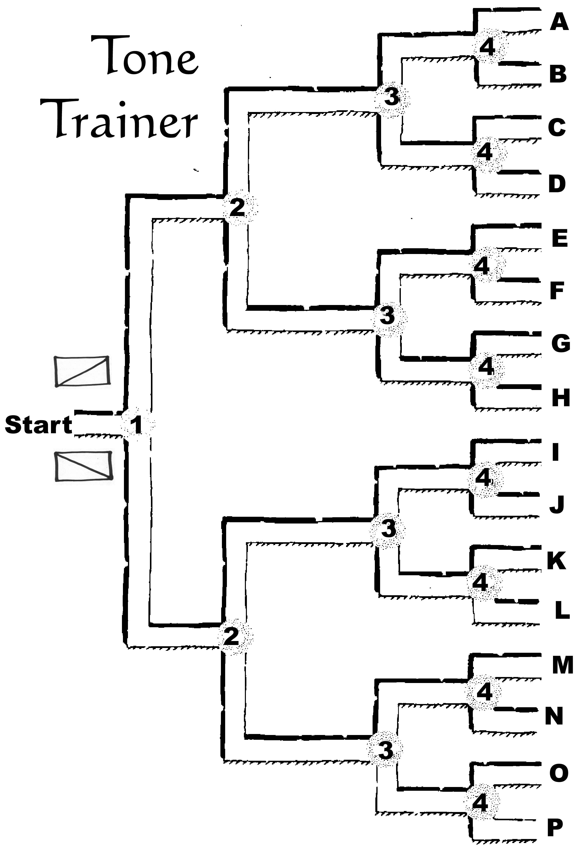

Proclaiming and referring
To explain the meaning of the falling and rising tones, David Brazil introduces the terms proclaiming and referring. These terms seem clear enough in pair 1 below. On the left, speaker B is proclaiming, or stating, that he or she isn’t tired. On the right, speaker B is referring back to what speaker A said, in order to make a comparison. For pairs 2, 3 and 4, it may be easier to explain the difference in meaning using the terms suggested in brackets.
In each case, B’s voice goes down at the end of the line in the left column and up at the end in the right column. Demonstrate this. Then say just B’s line and ask students to say if it is left or right.

Left (falling) | Right (rising)
1 A: You’re tired.  B: I’m not! (proclaiming)  2. A: Someone phoned.  B: Who? (asking an open question)  3. A: Are you OK?  B: Yes. (finishing)  4. A: When are you away?  B: I’m away tomorrow. (new word) | A: I’m tired.  B: I’m not. (referring)  A: The president phoned.  B: Who?! (asking to check)  A: Excuse me …  B: Yes? (continuing)  A: See you tomorrow.  B: I’m away tomorrow. (repeated word)

Keep in mind that pronunciation is not only about speaking, it’s also about listening. Students should be able to both recognise and produce the first two aspects of intonation: grouping words and stressing the most important one. However, many students have great difficulty producing tones, and it may be sufficient just to raise their awareness of them for receptive purposes.

Brazil, D The Communicative Value of Intonation in English CUP 1997

