TESOL – Spain

‘Marking’ speaking

Annie McDonald anniemcdonald@telefonica.net

1 Tasks

1 Think of hobbies. Use these categories to help.
art & music collections
games and puzzles
outdoor activities sports
Tell your partner what you do in your spare time.

2 Write true answers to the questions. Use for and since.
How long have you …..
had a driving licence?
known your best friend?
lived in the place you live now?
Ask the questions to a partner.

3 Put a –f in the correct order to make the conversation. Compare with a partner.

4 Work with a partner. Listen again and decide which questions Mr Williams answered well and which he answered badly. Say why.

5 Information gap activity.
Look at your train timetables but don’t show your partner. Find the missing information about the times and prices of trains to different places.

6 Role-play activity.
Work with a partner. Choose one of the jobs below and decide who is the interviewer and who is being interviewed. Tell your partner the job you are interested in. Role-play a job interview.



English Result Upper Intermediate, OUP.

7 Controlled practice / revision

1a) Work in pairs. Guess the meaning of the phrasal verbs in bold in these sentences. Check the phrasal verbs in V3.1 p.119.

- Have you ever set off very early to catch a flight?
- What’s the best way for tourists to get around your country?
- Do you bring back souvenirs from places you’ve been to?
- What’s the worst problem you’ve ever had to deal with on holiday?
- What information do you have to give the receptionist when you check into a hotel?
- What’s the earliest that you’ve had to check out of a hotel?
- Have you ever had to put up with noisy people in a hotel?
- Did anyone see you off when you last went on holiday?
- Did anyone pick you up from the airport or station when you got back?
- Are you looking forward to your next holiday?

1b) Work in new pairs. Take turns to ask and answer the questions in 1a). Ask follow-up questions if possible.

Have you ever had to set off very early to catch a flight?
Yes, I have, actually.
What time did you leave home?

face2face Intermediate, CUP.

2 Communicative feedback – broaden the frame!



3 Using the CEFR: components and criteria for communicative competence (spoken interaction)

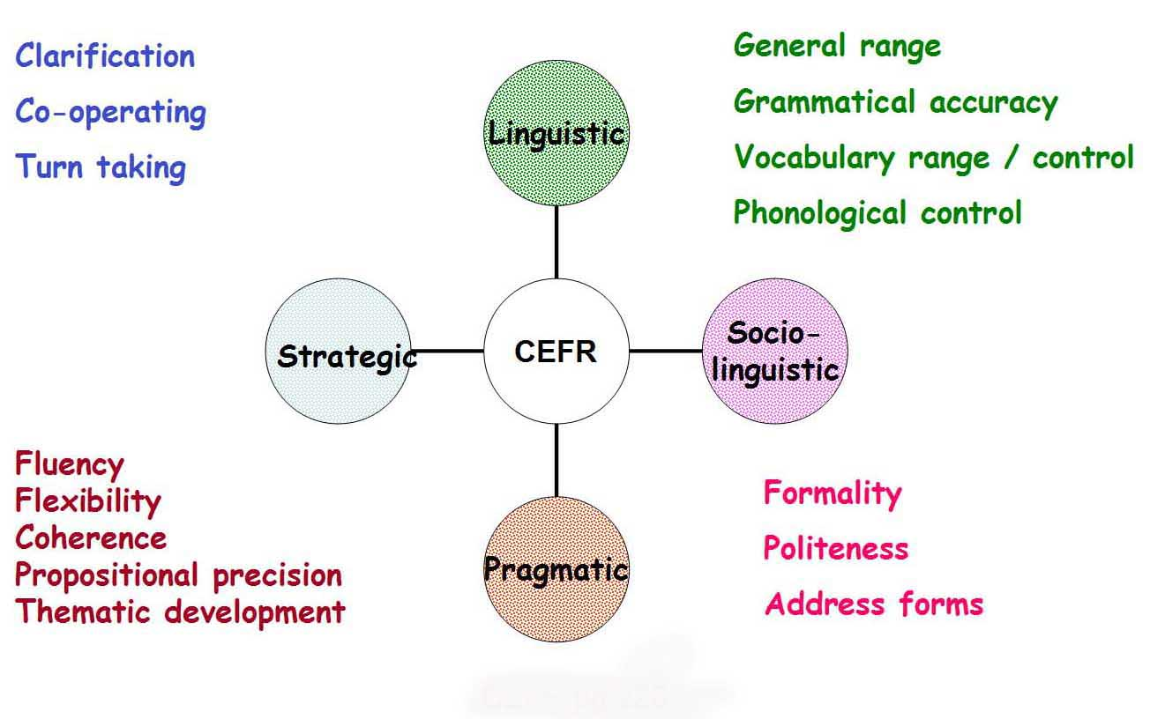
Snippets from CEFR descriptors – get a feel for categories and levels

B1

Gram accuracy Uses reasonably accurate repertoire of frequent patterns for predictable situations

Vocab range Has sufficient vocab to express self, some circumlocution, on most everyday topics

Socio-linguistic Aware of salient politeness conventions and responds accordingly

Fluency Keep going, with pauses

Coherence Links a series of shorter, discrete simple elements into linear sequence of points

Co-operating Uses basic language - keeps conversation going

Asking for clarification Asks someone to clarify or elaborate what said
B2

Gram accuracy Has relatively high degree of grammatical control

Vocab range Has good range of vocab on most general topics

Socio-linguistic Uses formal and informal registers

Fluency Produces stretches of language with fairly even tempo

Coherence Use a limited number of cohesive devices to link utterances into clear, coherent discourse

Co-operating Helps the conversation along (confirm comprehension)

Asking for clarification Asks follow-up questions to check understanding

- Devising task feedback prompts

A general marking menu for spoken interaction tasks

Language  (linguistic competence) | Does the student use vocabulary and grammar appropriately?  Does the student use accurate grammar and vocabulary?  Does the student sound intelligible?  Does the student use a range of structures and vocabulary?  Does the student use correct pronunciation?
Interaction  (socio-linguistic and strategic competence) | Does the student ask for repetition, or check and confirm understanding where necessary?  Does the student follow politeness conventions?  Does the student start, maintain and close the conversation?  Do the students help each other keep the conversation going?  Does the student respond appropriately?
Discourse  (pragmatic competence) | Does the student speak without hesitating too much?  Does the student present information logically?  Does the student link what they said to previous points?  Does the student get across the most important point?
Content  (optional) | Does the student complete all the stages?  Does the student cover all the points?  Does the student give enough information?

Some specific feedback prompts for task 7 (page 1)

Does the student …..
Linguistic competence

use 4 or more words or phrases for travel?
sometimes use the present perfect appropriately?
try to use intonation to ask and confirm?
mainly / mostly pronounce –ed endings?

Socio-linguistic competence

start the conversation with a general question?
ask and answer appropriately?
sometimes ask follow-up questions?

Pragmatic competence

tell holiday events in chronological order?
use singular / plural pronouns appropriately?
use travel words with little hesitation?
usually link their ideas?
use fillers where necessary?

Strategic competence

check if they don’t understand?
ask for help if necessary?
repeat information to check understanding?
5 Try it out – devise your own prompts and see how you get on in class

Task 7: task feedback prompts

 | Does the student …. | Mario | Victoria
Language 1
Language 2
Interaction 1
Interaction 2
Discourse

References

Black, Paul; Wiliam, Dylan, Assessment and classroom learning Assessment in Education, Mar 1998 5.1; Academic Research Library *

Council of Europe. 2001. Common European Framework of Reference for Languages: Learning, teaching assessment. Cambridge: C.U.P.

J A van Ek & J L M Trim, Breakthrough, EALTA web-site (www.ealta.eu.org/resources)

J A van Ek & J L M Trim, Threshold, (Revised Edition), 1998, Council of Europe, CUP

J A van Ek & J L M Trim, Waystage (Revised Edition), 1998, Council of Europe, CUP

J A van Ek & J L M Trim, Vantage, 2001, Strasbourg, Council of Europe

www.cambridgeesl.org English Profile (Reference level descriptions for English)

www.eaquals.org European Association for Quality Language Services (follow link for EAQUALS British Council Core Curriculum download, and Can dos as checklists for all skills)

* If you would like a copy of this paper, feel free to email me

